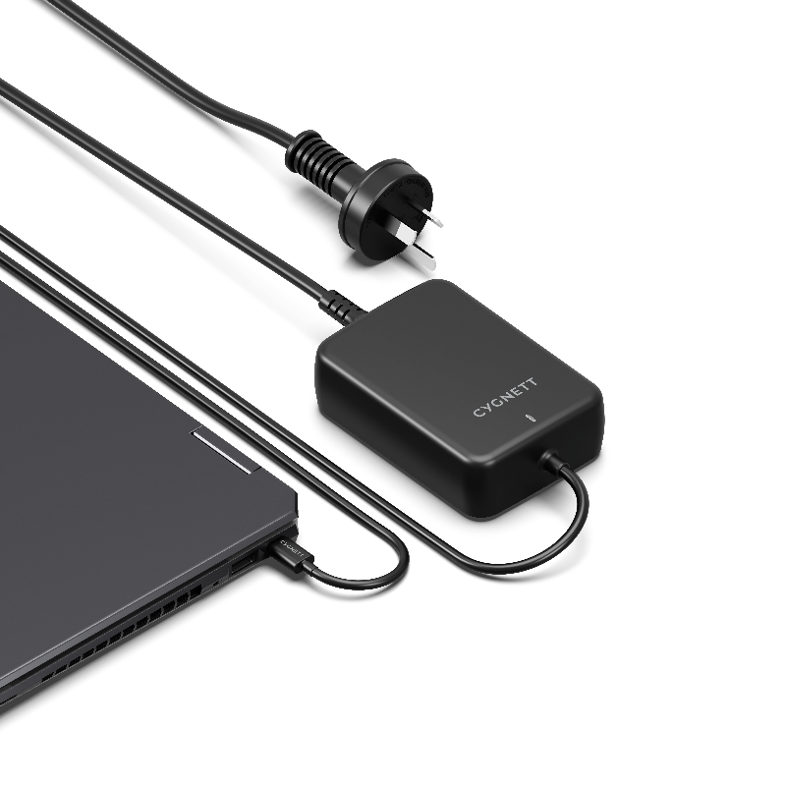


SKU: CY4531PDWCH

POWERMAXX
140W GaN USB-C Laptop Charger

Charge your laptop at lightning speed with the PowerMaxx 140W Wall Charger. Utilising advanced GaN technology, this charger offers a smaller, lighter design with high thermal conductivity and low thermal resistance.
Enjoy superfast charging on the go with an integrated USB-C cable for added convenience, making it an ideal companion for travel or work.

PRODUCT HIGHLIGHTS
PRODUCT HIGHLIGHTS

- Charge powerful laptops, phones & tablets
- 140W USB-C Power Delivery
- GaN technology
- Integrated 1M USB-C charging cable
- 2-year warranty
Charger faster and smarter with GaN
With advanced GaN technology, this charger delivers power to your laptop faster than traditional chargers. It's also more energy-efficient, reducing heat buildup and keeping your devices cooler. This not only boosts performance but also helps prevent overheating, making GaN-powered devices safer and more dependable for everyday use.

140W laptop charging
Unlock an incredible 140W USB-C PD charging power for USB-C laptops, including MacBook Pro, HP, Dell, Microsoft Surface and more. Charge with confidence knowing this laptop charger has been expert-tested and rigorously designed to meet the highest standards. Stay powered without compromising on safety.

Fast charging a wide range of USB-C devices
Charge popular USB-C devices like tablets, drones, phones that accept USB-C charging.

Integrated 1M USB-C charging cable
No additional charging cables needed, this charger comes with an integrated 1M USB-C cable that plugs directly into your laptop or other USB-C devices.

SPECIFICATIONS

INPUT:
- AC: AC 100-240V~,50/60Hz, 1.5A

OUTPUT:
- USB-C PD 140W

TOTAL OUTPUT: 140.0W Max

